Guidelines for Preparing Two Pages Extended Abstract on FEAST Usage

First Author1, Second Author2, and Third Author2,*

1Institute1, ISRO – 695022, India

2Institute2, ISRO – 695022, India  
\**Communicating Author, E-Mail: abc@xyz.ac.in*

1. Introduction

This document describes the format for the two pages extended abstract on FEAST usage for the 8th National Finite Element Developers’/ FEAST Users’ Meet (NAFED 08) to be held offline, in February, 2025. The purpose of this document is to ensure a reasonable degree of consistency among the papers in the final proceeding. This document has been created in the required format. It can therefore be used as a template by typing over the existing content. The font style and size used in the different areas of the template must be strictly adhered to.

The extended abstracts shall be strictly limited to two pages, which will be published in the Extended Abstract Volume for distribution among the meet participants, if accepted.

1. Problem Description [Head 1]

The body of the extended abstract should comprise a detailed and systematic illustration of the work carried out. The extent of information provided must be suitable for the target audience. Provide definitions for all the terminologies at the beginning and adhere to them consistently.

Except for the introduction, the headings provided in the template are only exemplary. The title of the headings may be chosen as appropriate. No specific heading titles are mandated but typical examples include problem description, methodology, assumptions, analysis, observations, and so on. The body is composed of several sections and subsections titled with appropriate topical headings in a four-level organisation. The titles of the various levels are formatted using template styles [Head 1] through [Head 4].  The paragraph text must be of [Normal] style tag, which is 10 point, regular.

* 1. [Head 2]

The [Normal] style tag must be used for paragraph text which is 10 point, regular. The equations need to be formatted as per the following with the numbering scheme depicted.

|  |  |
| --- | --- |
| $$D_{m}=\frac{E}{1-ν^{2}}\left[\begin{matrix}1 & ν & 0 \\ ν & 1 & 0 \\ 0 & 0 & \frac{1-ν}{2}\end{matrix}\right].$$ | (2.1) |

### [Head 3]

The [Normal] style tag must be used for paragraph text which is 10 point, regular.

#### **[*Head 4*]**

The [Normal] style tag must be used for paragraph text which is 10 point, regular. The extended abstract can at most contain four levels of headings. The following Table 2.1 shows how a table should look like in the extended abstract.

Table 2.1. Sample Table caption

|  |  |
| --- | --- |
| **Column 1** | **Column 2** |
| 1 | Content |
| 2 | .. |
| .. | .. |

None of the paragraphs in the entire extended abstract are indented. The figures shall be formatted as per the sample below along with caption as described. As far as possible, the figures included in the document should be of high resolution.

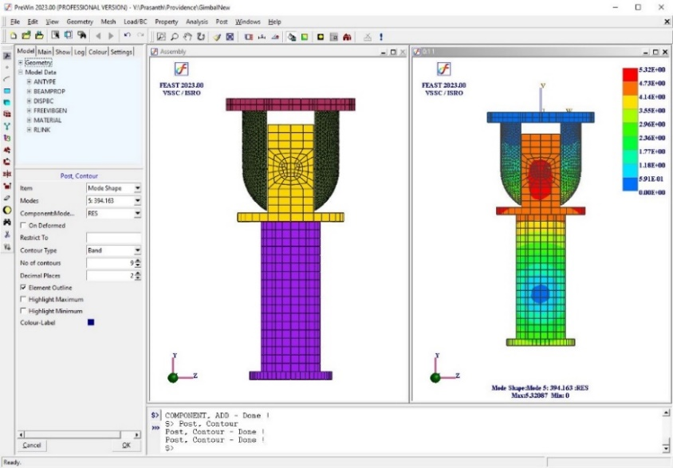

Figure 2.1. A figure caption is always placed below the illustration and centered.

1. Results and Discussion

Whenever possible, use vector graphics instead (Figure 3.1).

Figure 3.1. A figure caption is always placed below the illustration and centered.

For the citation of references, it is preferred to use square brackets and consecutive numbers. The following bibliography provides a sample reference list with entries for journal articles [1], an LNCS chapter [2], a book [3], proceedings without editors [4], as well as a URL [5].

References

1. Author, F.: Article title. Journal 2(5), 99–110 (2016).
2. Author, F., Author, S.: Title of a proceedings paper. In: Editor, F., Editor, S. (eds.) Conference 2016, LNCS, vol. 9999, pp. 1–14. Springer, Heidelberg (2016).
3. Author, F., Author, S., Author, T.: Book title. 2nd edn. Publisher, Location (1999).
4. Author, F.: Contribution title. In: 9th International Proceedings on Proceedings, pp. 1–2. Publisher, Location (2010).
5. <http://www.springer.com/lncs>, last accessed 2016/11/21.

Acknowledgements

If the Acknowledgments section is not required, delete this heading and text.